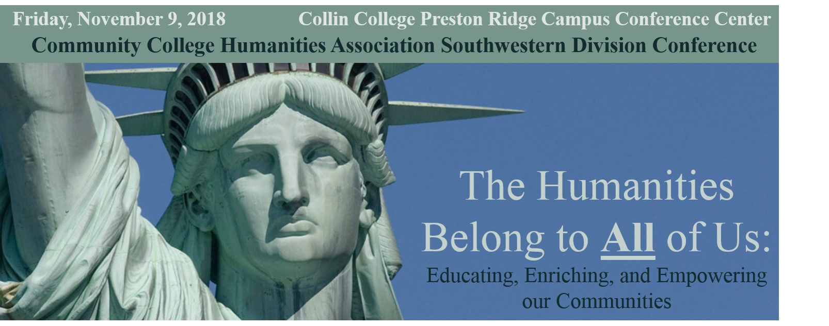
North Texas Community College Consortium and the
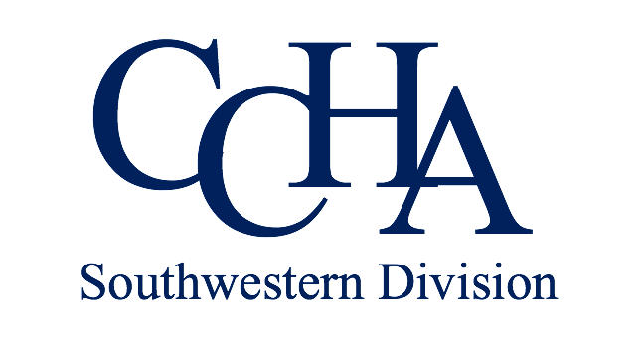
November 9, 2018
Collin College Preston Ridge Campus Conference Center
9700 Wade Boulevard, Frisco, TX 75035
Registration Opens at 8:30am
All attendees must pay the conference registration fee and CCHA membership dues.
Conference Registration
Early Bird Registration (Before September 30): $35
Late Registration: $50
CCHA Membership Dues
$50 full time college professors, $15 for adjuncts, public school teachers, independent scholars, and emereti, $10 for students
Pay Your CCHA Membership Dues
https://www.cchumanities.org/about-ccha/membership/individual/apply-online/

Conference Theme
The Southwestern Division of the Community College Humanities Association conference will address the ways in which we as scholars and practitioners in the humanities serve our communities. We will examine how humanities scholars act as conservationists of the arts and ideas, build coalitions with humanitarians beyond the academy, empower citizens to become discriminating thinkers and communicators, and enrich non-humanities’ fields through our commitment to human flourishing. We ask you to join us as we blaze the trail for the future of the humanities.

Conference Format
This year’s conference will be a one-day event. Rather than having panel presentations, we will have two keynote speakers, one in the morning and one at lunch, followed by four simultaneous afternoon breakout sessions. Each breakout session is designed around a particular theme. Please choose one of these sessions to attend (listed below). Once we have received your topic choice, we will email you links to articles and materials to encourage discussion at the breakout session. The conference will conclude with an hour-long meeting addressing the future of the Southwestern Division of CCHA.

• Breakout Session 1: “Preserving our Local Treasures: The Humanities and Conservation of Regional Art, History, Culture, Thought, and Traditional Ways.”
This topic will address the importance of understanding and maintaining our local and regional knowledge in the face of increasing homogenization and globalization. This session may be of particular interest to regional historians, archivists, anthropologists (folk ways), record keepers, collectors, and linguists. Participants can look into the history of the preservation and collection of artifacts and examine the motives behind such projects (such as “local color” literature).
Some questions to consider: Why do we have this desire to maintain heritages? When is it better for certain artifacts to go (Confederate monuments, for example)? How do we determine what is worth keeping in a world of clutter, mass culture, and overflow of information. What stories do we want to tell the future? Participants would be encouraged to use this session to help them create panels/presentations for the next CCHA conference.

• Breakout Session 2: “The Humanities beyond the Academy: Fostering Relationships between College Scholars and Public Intellectuals, Artists and Advocates for the Humanities.”
This topic investigates the benefits of creating symbiotic relationships between the academy and public humanitarians. People with whom scholars in the academy can dialogue and collaborate include public librarians, theatre, dance, and music directors, poets and authors, museum curators, gallery owners, local historians, members of religious and cultural institutions, political activists, leaders of non-profits, public radio and television programmers, and writers of print/internet news media.
Some questions to consider: Why should we foster these relationships? What can be gained, particularly in a time when the humanities are to some degree in peril? How can we mutually benefit one another? Might anything be lost (for example, subject matter being misrepresented or “watered down” for public consumption)? How can broadening our relationships help us better reach either underserved communities or communities that have not been recognized for their contributions? Which strategies for humanities advocacy have been successful in the past? Not successful? Can building networks enable us to challenge the labels of intellectual elitism or “Ivory Tower” exclusionism? How wide should we cast our nets? What factors keep us from being more engaged in building these relationships and what can we do to mitigate them? Participants are encouraged to use this session to help them create panels/presentations for the next CCHA conference.

• Breakout Session 3: “Communication Breakdowns: Fact/Fiction/Fake News and the Need for Truth.”
This topic will explore how (or even if) we can sort through the noise of modern discourse and find the pearls that are so necessary for a civil and reasonable society to continue. Participants could discuss the necessity for developing critical thinking and interpretive skills in order to separate good information/ideas from suspect ones. The ways in which information and opinions are disseminated (that is, the language and style of their presentation and the media that present them) could also be investigated as having a powerful influence on our beliefs, values, and behaviors. Finally, one might want to consider how fictional texts can create different kinds of “truth.”
Some questions to consider: How can we better prepare our students and ourselves to properly interpret information and determine what is significant, what is spin, and what is false? How can we better resist emotional manipulations, distortions, and/or distractions that lead us away from a more subtle and discriminating evaluation of the events unfolding before us? When does our social compliance become dangerous? How can we communicate clearly, rationally, and accurately so as to change the quality of discourse? Or is it a losing battle? Is it better to create divisions out of belief in our cause(s)? Or is compromise a better option? Do fictional texts (including film, artworks, dance performances) play a role in helping us to discern the truth? Participants would be encouraged to use this session to help them create panels/presentations for the next CCHA conference.

• Breakout Session 4: “Why We Still Matter in a Tech-Saturated World: The Differences Humanities’ Courses and Degrees Make.”
This topic will consider if students who take courses in the humanities or receive liberal arts degrees can make unique and meaningful contributions to businesses and tech companies. Participants are invited to reflect upon the popular notion that studying the humanities and receiving liberal arts degrees are irrelevant in a society that requires workers for its business and tech sectors and that frequently views technology as the solution to all problems. Participants could also examine whether thinking about courses and degrees in terms of their practicality for employment is necessarily a good idea.
Questions to ponder: What is the history behind the United States’ higher educational system, in which the humanities are considered foundational? Should we dispense with this model in order to graduate students more quickly in their chosen majors? What exactly do people with humanities’ degrees end up doing in “the real world?” What does knowledge of the humanities add to major tech companies such as Facebook, Amazon, Apple, and Google? What is divergent thinking? Why might we need mental “explorers?” How do the humanities foster creativity and critical thinking in the business world? Do we need humanists to remind us of the unintended consequences that can occur if a new technology is embraced? Is the division between STEM and the liberal arts over-stated? What other valuable skills for the "real world" do students learn from the humanities (for example, enhancing their relationships, dealing with suffering, contributing to society as citizens and volunteers, finding joy and meaning in life)? Participants are encouraged to use this session to help them create panels/presentations for the next CCHA conference.

Community College
Humanities Association

A digital version of this form can be completed through https://ntccc.wufoo.com/forms/2018-ccha-southwestern-division-conference/. Or you may fill out the following form and mail it, along with a check for the necessary amount, to the address at the bottom of this page. Questions? Email lsears@collin.edu

Name: ___________________________________________________________________

Academic Title(s): ____________________________________________________________________

Discipline(s)/Field(s): _________________________________________________________________

Institution Name: ____________________________________________________________________

Institution Address: __________________________________________________________________

City: _________________ State Abbreviation: _______________ Zip Code:_________________

Email(s): ____________________________________________________________________________

Office Phone: _______________ Other Phone (☐ Home or ☐ Mobile): _______________

Name to appear on badge: _____________________________________________________________

For New and Renewing Members ONLY: Desired Username for Website: ______________________

Select a Breakout Session

- Preserving our Local Treasure: The Humanities and Conservation of Regional Art, History, Culture, and Thought _____________
- The Humanities beyond the Academy: Fostering Relationships between College Scholars and Public Intellectuals, Artists and Advocates for the Humanities _________________
- Communication Breakdowns: Fact/Fiction/Fake News and the Need for Truth _____________
- Why We Still Matter in a Tech-Saturated World: The Differences Humanities’ Courses and Degrees Make _________________

Vegetarian Meals?: ☐ Yes -OR- ☐ No (Please be sure to select one)
Please indicate any food allergies: _____________________________

Registration

☐ Early-Bird Registration, before September 30 ($35 Personal/Institutional Check)
☐ Late Registration, after September 30 ($50 Personal/Institutional Check)

Make Registration Checks Payable to:
North Texas Community College Consortium
1155 Union Circle #310800
Denton, TX 76203

Notes:

____________________________________________________________________________________

