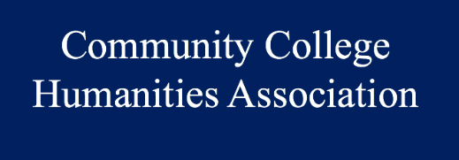
Affiliated Fellowship
AAR-CCHA Affiliated Fellowship 2017

Name
Title
Institution
Address
Email
Phone (Primary)
Years Teaching
Subject-Matter-Expertise
Project Title

All applications must be accompanied by:
- Letter of interest to the CCHA evaluation committee;
- Detailed research proposal. Applicants may structure the proposal as they see fit, but it must include a section on how this research is relevant to the applicant’s work AND the advancement of the humanities at community colleges;
- CV; and
- At least 3 letters of recommendation.

Anyone selected for a research fellowship must, within two years, commit to:
- Presenting at one CCHA National conference on research results/findings; and
- Writing for CCHA’s Community College Humanities Review one essay on the research findings (3,000 + words) for publication.

Application Deadline: 20 January 2017
Please email all documents to Andrew Rusnak at ARusnak@ccbcmd.edu

