Workshop Information and Deadline
This workshop is primarily for college and university faculty members (full time and adjunct or part-time) who teach survey courses. It is also open to independent scholars and friends of the humanities who are genuinely interested in American history and culture.

The fee for the workshop is $799. The workshop is filled on a first-come, first served basis. A waiting list will be kept. Should a space become available, you will receive an e-mail message and have three days to respond.

Fee for GWU single room with shared bath including linen and towel is $400.00

Total cost for workshop and single room
per person is $1199.00

Deadline for Application is May 30 and Payment is June 15, 2017
Please go to www.cchumanities.org to register for this workshop. Send payments to: Cathy Feehley, CCHA Admin, c/o CCBC, Romadka College Center 223, 7201 Rossville Blvd., Baltimore, MD 21237 -OR- CFeehley@ccbcmd.edu

For More Information - Please Contact:
Project Director, Paul Benson at leebee@dcccd.edu or 214-860-8738

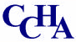

Survey Courses Project:

Workshops in American History and Culture

The Progressive Era

1890-1920

Washington, DC

July 9-14, 2017

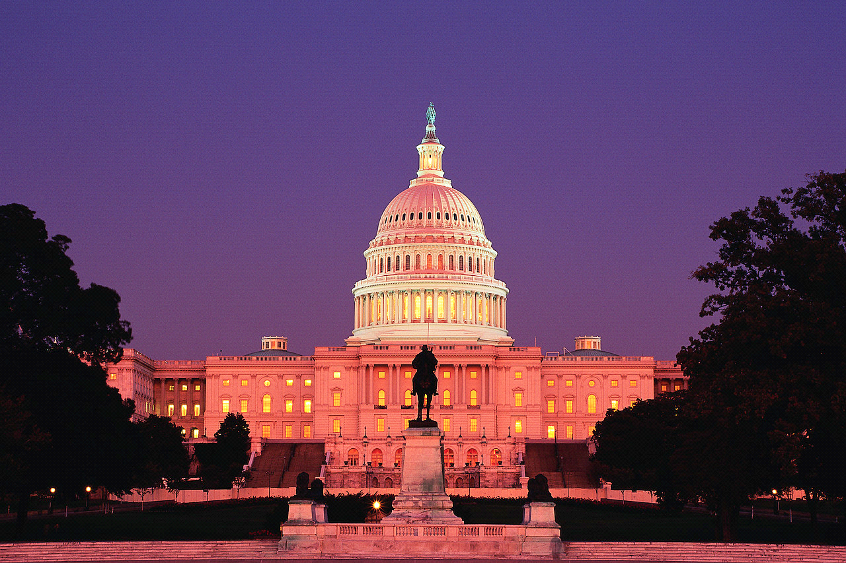

What is the Survey Courses Project?
The Community College Humanities Association in cooperation with the White House Historical Association and the US Capitol Historical Society has a new summer program to college and university teachers of survey courses.
Survey Courses Project: Workshops in American History and Culture is designed to provide fresh insights and new information to enrich survey courses. It is for instructors who have little time or opportunity to do research or take additional graduate-level coursework to improve their survey classes.

The Progressive Era 1890-1920 is the focus of 2017’s summer program. It it will give professors new material on one of the most important periods in American history. Centered in Washington, DC, this workshop is conceived to improve survey courses through scholarly lectures and discussions, Library of Congress research, and field trips.
This workshop will be held at the facilities of the White Historical Association, US Capitol Historical Society, Smithsonian, Library of Congress and other significant historical sites in the Washington, DC area. Scholars and specialists will make presentations to the group, lead discussions, and assist with special research opportunities.

A Sample of Workshop Scholars:

Paul Finkelman, Senior Fellow, Penn
Program on Democracy, Citizenship, and Constitutionalism University of Pennsylvania will speak the critical US Constitutional crises during the Progressive Era
Pamela Scott, Independent Architectural
Historian will speak on the US Capitol Building during the Progressive Era
Don Kennon, Education Director Emeritus
of the US Capitol Historical Society will make a presentation on the historic development of the US Capitol during the Progressive Era
Steve Livengood, US Capitol Historical
Society’s Chief Capitol Guide will give participants a behind-the-scenes tour of the US Capitol with emphasis changes to the building during the Progressive Era
Melvin Urofsky, Professor Emeritus
Virginia Commonwealth University, will speak on Louis Brandeis as a product of the Progressive Era
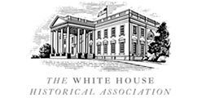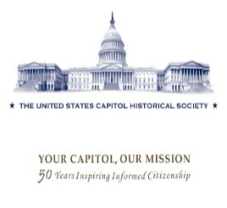
Tentative Workshop Schedule

Sunday, July 9
6-8 PM Dinner and Orientation
@ GWU’s Mt. Vernon Campus
Monday, July 10
9-Noon The White House Progressive Era
2- 5 PM “Discovering the Library of Congress” Tour of the Thomas Jefferson Building
Obtaining an Library of Congress User Card
6:30-9 PM Historic Walking Tour /Part 1
Tuesday, July 11
9 AM “Congressional Activity during the Progressive Era”
2-5 American History during the Progressive Period at the Smithsonian
6-8 PM Optional Marine History and Marine Drum & Bugle Corps
Wednesday, July 12
9-Noon “History of Washington, DC during the Progressive Period” with Don Kennon
2-5 PM Research Time at the Library of Congress
Free Evening
Thursday, July 13
9-Noon “History of the Supreme Court During the Progressive Era”
2-5 PM Tour of the US Supreme Court
6:30-9 PM Historic Walking Tour/Part 2
Friday, July 14
9-Noon “The Progressive Era & the Constitution” with Paul Finkelman

2-5 PM Special Tour of Capitol Hill by Steve Livengood
6-8 PM Dinner at talk by Paul Finkelman @ GWU’s Mt. Vernon Campus

